WEEK 6: SECURITY REVIEW (Microsoft Defender)
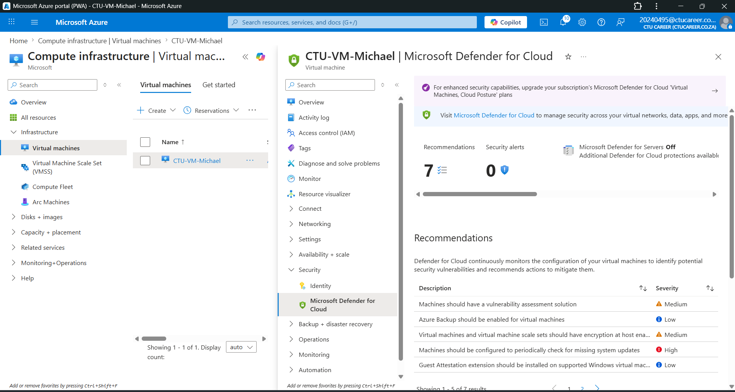

Microsoft Defender for Cloud was accessed and the free Foundational CSPM plan was active. Security recommendations were reviewed to identify potential risks such as open ports and missing updates. Basic security improvements were applied where possible.

